Exercise 1

Write programs for following two different algorithm for finding that given number is prime or not

|  |  |
| --- | --- |
| Frist Algorithm | Second Algorithm |
| for i 🡨 2 to n-1  if i divides n  n is not prime number | for i 🡨 2 to √n  if i divides n  n is not prime number |

**SOURCECODE:**

#include <iostream>

#include <math.h>

using namespace std;

void prime1(int n)

{

bool flag=false;

int count=0;

for (int i =2;i<n-1;i++)

{

count++;

if (n%i ==0)

{

flag =true;

break;

}

}

if(flag)

{

cout<<n<<" is not Prime number "<<endl;

cout<<"Time Taken: "<<count<<endl;

}

else

{

cout<<n<<" is prime number "<<endl;

cout<<"Time Taken: "<<count<<endl;

}

}

void prime2(int n)

{

bool flag=false;

int count=0;

for (int i =2;i<sqrt(double(n));i++)

{

count++;

if (n%i ==0)

{

flag =true;

break;

}

}

if(flag)

{

cout<<n<<" is not Prime number "<<endl;

cout<<"Time Taken: "<<count<<endl;

}

else

{

cout<<n<<" is prime number "<<endl;

cout<<"Time Taken: "<<count<<endl;

}

}

int main()

{

int n;

cout<<"Enter a number to find the Prime Number:"<<endl;

cin>>n;

cout<<"\n*************************************"<<endl;

cout<<"1st Algorithm\n"<<endl;

prime1(n);

cout<<"*************************************"<<endl;

cout<<"\n*************************************"<<endl;

cout<<"2nd Algorithm\n"<<endl;

prime2(n);

cout<<"*************************************"<<endl;

system("pause");

return 0;

}

**SCREENSHOT:**

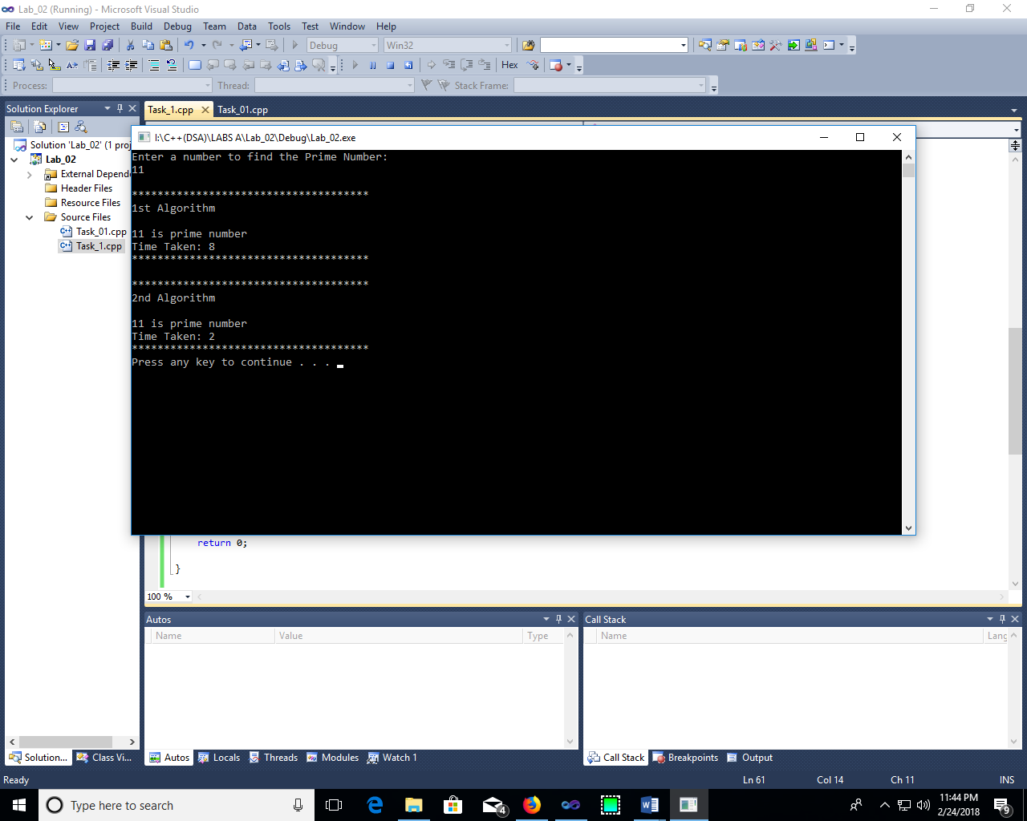

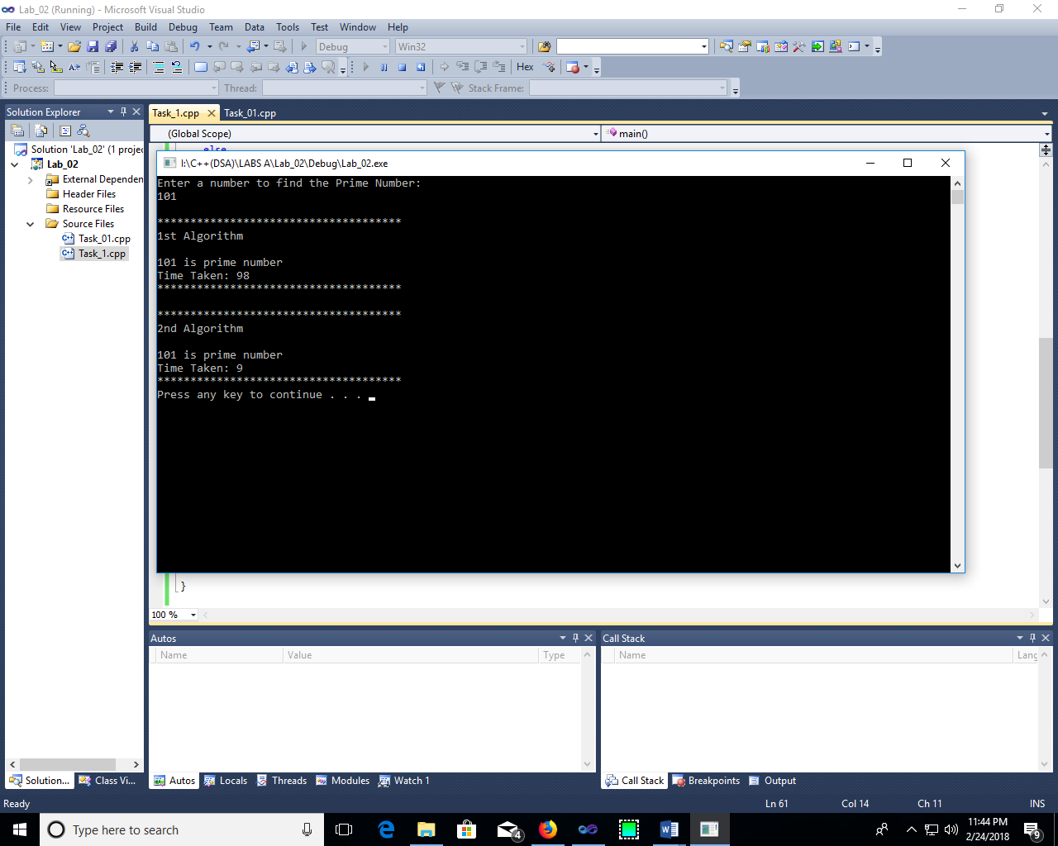

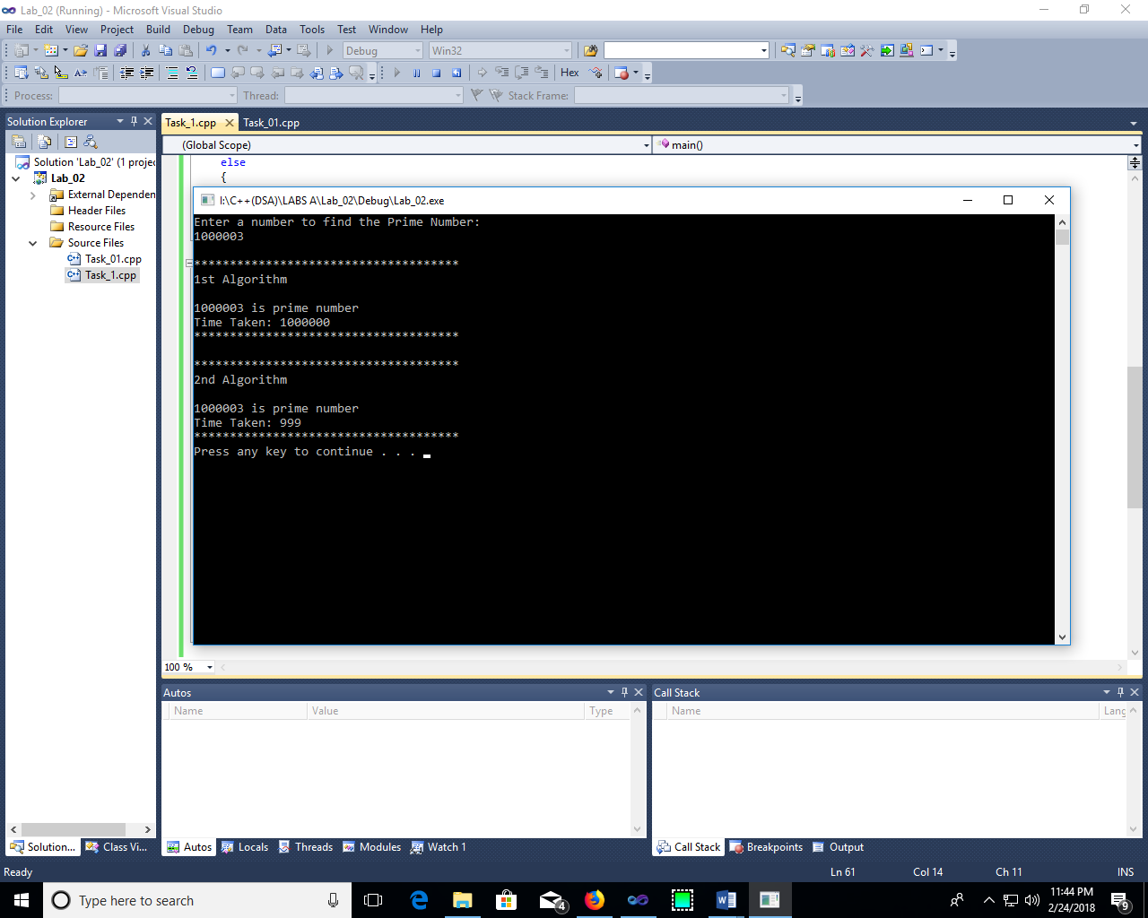

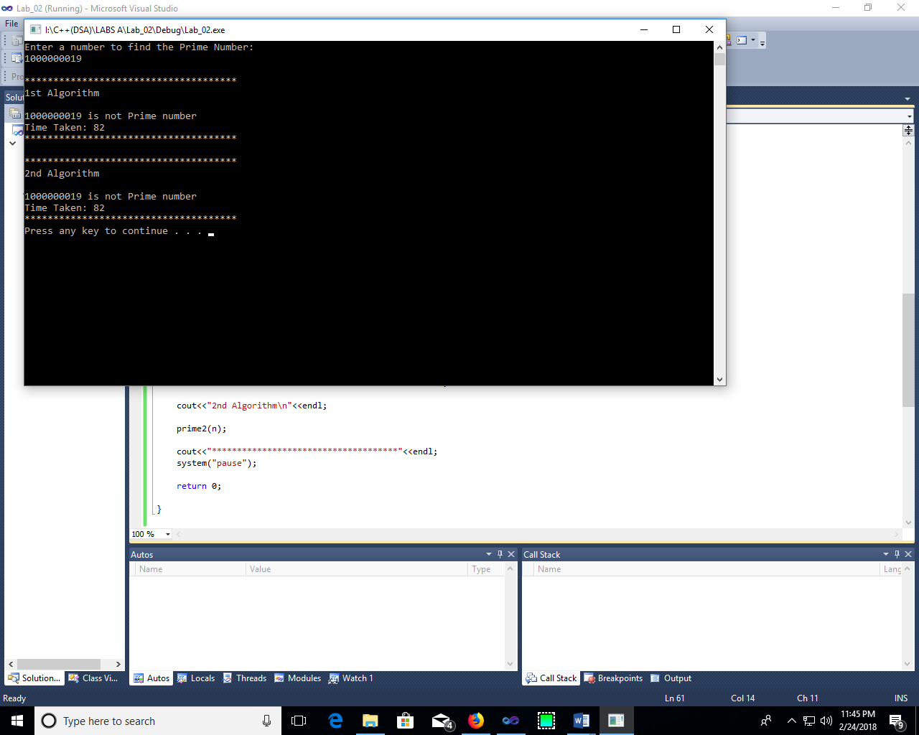

**CONCLUSION:**

The time complexity of the square root method is much better than the time complexity of remainder method.